Showcase your work

Congratulations on earning your Google Data Analytics Certificate! Now it’s time to let the world know about the skills you gained to help advance your career and share some of the artifacts you created along the way. We recommend adding the completion of this certificate to your resume and LinkedIn profile. Read on and follow these tips to get started.

**Adding the Google Data Analytics Certificate to your resume and LinkedIn profile**

You may have already started on a data analyst resume earlier in the certificate. If not, there are a variety of digital templates for creating your resume available at [Enhancv](https://app.enhancv.com/industry-examples), [Big Interview](https://googlecerts.biginterview.com/), [Google Docs](https://applieddigitalskills.withgoogle.com/c/middle-and-high-school/en/create-a-resume-in-google-docs/overview.html) or [Microsoft Word.](https://support.microsoft.com/en-us/office/use-a-template-to-create-a-resume-6053fbbb-94d8-471e-9957-49f4e7ab6fb8) You can find additional resume creation guidance in this lesson from Applied Digital Skills: [Start a Resume](https://applieddigitalskills.withgoogle.com/c/college-and-continuing-education/en/start-a-resume/overview.html)

**Update your Education or Licenses and Certifications section**

* To add the completion of this certificate to your resume, update your ***Education*** or ***Licenses & Certifications*** section.
* To add the completion of this certificate to the ***Licenses & Certifications*** section of your LinkedIn profile, follow the [steps listed in this article.](https://www.linkedin.com/help/linkedin/answer/44644)

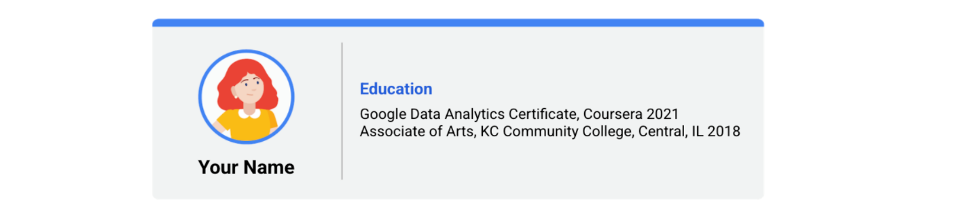Education: google data analytics certificate, coursera 2021 associate of arts, KC community college, central, IL 2018

**Update your Skills section**

* If applicable, update the ***Skills*** section of your resume. Below is a comprehensive list of skills that this certificate was designed to help you develop that you could potentially add.
* To update the ***Skills & Endorsements*** section of your LinkedIn profile, follow the [steps listed in this article.](https://www.linkedin.com/help/linkedin/answer/4976)

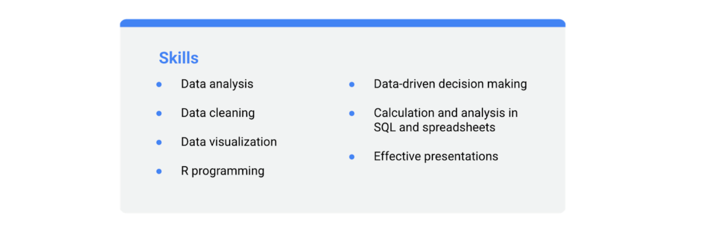- data analysis - data cleaning - data visualization - R programming - data-driven decision making - calculation and analysis in SQL and spreadsheets - effective presentations

**Update your Summary or About section**

* If you have a ***Summary*** section in your resume, you can include this certification as a qualification.
* To include a summary that mentions this certification in your LinkedIn profile, update your ***About*** section by following the [steps listed in this article.](https://www.linkedin.com/help/linkedin/answer/92157)

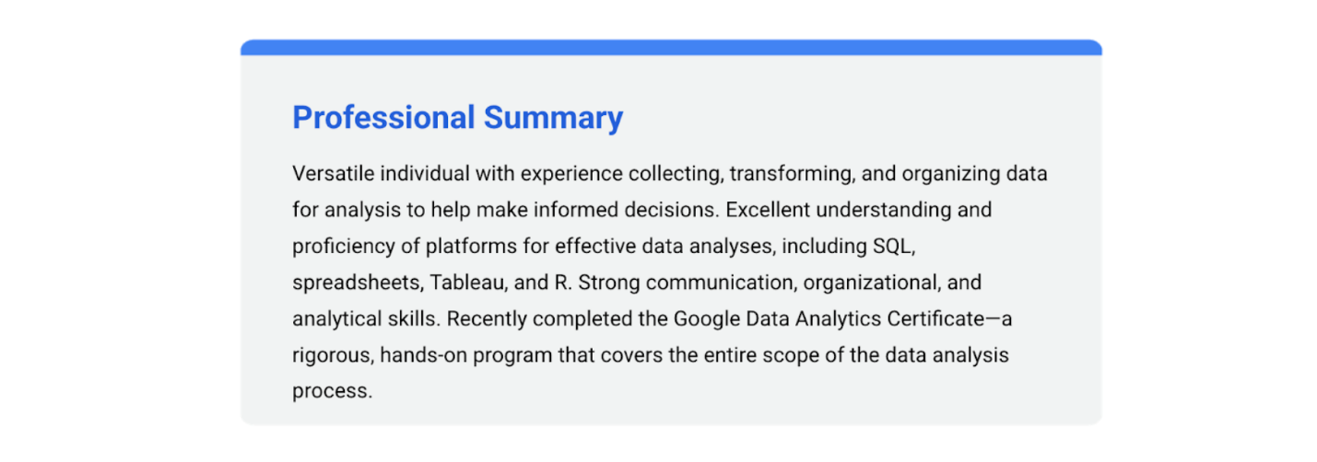Versatile individual with experience collecting, transforming, and organizing data for analysis to help make informed decisions. Excellent understanding and proficiency of platforms for effective data analyses, including SQL, spreadsheets, Tableau, and R. Strong communication, organizational, and analytical skills. Recently completed the Google Data Analytics Certificate- a rigorous, hands-on program that covers the entire scope of the data analysis process.

**Add your badge**

Check out the next course item to learn how to claim your certification completion badge and add it to your LinkedIn profile!